Exploring Small Examples Challenge Problems
There’s a very important idea we left out of the last lesson. Instead of just making a table of numbers for small cases and trying to fit a function to it, you want to understand why those numbers are happening. Two reasons for this:
- As the examples grow larger, it’s easier for you to be wrong about your numbers (if you’re just counting by hand) unless you have a clear reason why.
For example, in the maximum regions problem you can draw 5 lines, but you may not be sure your particular arrangement actually generates the maximum number of regions. That means the numbers in your table might be wrong.
- The reason why might suggest an underlying logic that leads to a simpler way to look at the problem than trying to fit a function.
Here are some additional problems with a range of difficulty levels. You should still explore small examples, but this time focus on the process you use to generate the examples and try and ask why any numeric patterns are happening.
1). Lockers.
You may have seen this problem before. Say you have a row of 36 lockers, all closed. We’ll send all 36 students down the row of lockers. They’ll either open or close the locker doors: if a locker door is open, they’ll close it and if the locker door is closed, they’ll open it.
The first student does this to all the lockers. The second student who runs down the line only does this for every other locker (skipping one in the middle). The third student who runs down the line only does this for every 3rd lock (skipping two in between). If there are n lockers, there will be n total students who run down the line.
At the end of this whole process, which lockers are open? How can you describe their position mathematically? Why those lockers?
If you’ve seen this problem before, I have some other questions I’m curious about:
What if the lockers are numbered 1 to n but organized in a circle. Each student can choose where in the circle they want to start, and then runs the full circle opening and closing lockers, skipping the number they need to, until they’ve completed the full circle. I want to know what kinds of outcomes are possible now. Could we end with all lockers fully opened or closed?

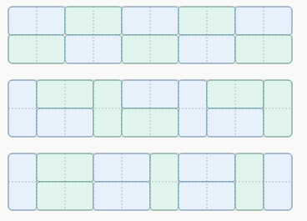
2). Domino tilings.
Here are 3 examples of how you can cover a 2 by 10 grid with dominoes sized 1 by 2. If you can perfectly cover all the squres without overlaping the dominoes or having them hang off the edge of the grid, we call that a tiling of the grid. (Imagine it’s your counter-top and you’re literally placing tiles down to cover the surface).
How many total different tilings are there for a 2 by n grid? You should see a pattern in the numbers you get when you exlore: why is it happening?
3). Survivor’s circle.
There are n people wearing hats with numbers 1 to n on them. Let’s arrange everyone in numerically increasing order in a circle (so person 1 has person 2 to their right, but person n to their left).
Starting at person 1, count around the circle and remove every other person. When you’ve completed a full circle, just keep going, eliminating every other person, until only one person is left. We’ll call that last person the survivor.
What position is the survivor standing in?
4). Maximum Regions. If you didn’t try this problem yet, give it a try. here it is:
With 9 straight lines, I can create different numbers of regions in a square, depending on how they’re arranged.
Here are examples where 9 lines can make 18 regions, or 30 (?) regions.
What’s the largest number of regions I can make with 100 lines? With 200 lines?

I specifically want you to try and give a clear answer to why does the growth in the table of small results look the way it does ? In other words, if I go from, say 5 lines to 6 lines, the maximum number of regions I can get grows by a specific number. Why that number?
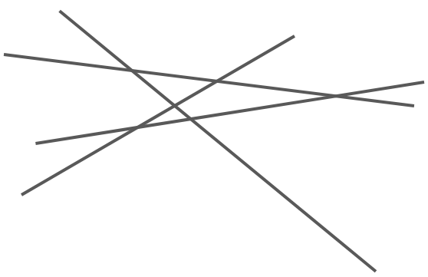
5). Max number of triangles.
Now for a related problem.
Here’s a picture of 4 lines. If you count carefully, you’ll see there are 4 total triangles.
If I use n lines, what’s the maximum number of triangles I can get?
Just as before, try and figure out how new triangles get generated when you add another line.

3 Unsolved Problems
The problems above may feel like toy problems, or puzzles that aren’t serious mathematics. Here are a few problems with a similar feel that certainly are serious mathematics and for which the solutions aren’t currently known.
What can you do with them? You can still explore small cases, try and see interesting things. For some of the problems you maybe able to make a conjecture about a possible answer.
Something mathematicians do when they can’t find an answer is to try and find an upper bound or a lower bound on the answer. For example, they’d say: “I don’t know what the answer is, but I know it has to be bigger than 107”. In that case, 107 would be a lower-bound on the answer. If you can give a convincing reason the unknown anwer must be less than 10,000, then you’d say that 10,000 is an upper bound on the answer.
A lot of progress on big important problems involve making better upper and lower bounds – that is, bounds that are closer to the real answer.
6). Klein-Erdős–Szekeres "Happy Ending" problem.
The story: This puzzle was invented by a young chemical engineering student named Esther Klein when she was an undergraduate. She brought it to her two friends, Paul Erdős and George Szekeres who worked on it together. The happy ending isn’t that they solved the problem, but that Klein and Szekeres fell in love while working on it together and ended up marrying each other! Remember: working on math problems together is a great way to get close to someone!
The problem.

Let’s work our way up to it.
Clearly 4 dots on the plane might form the vertecies of a convex 4-sided shape, as these ones do.
a) Find a way of placing 4 points so that they don’t form the verticies of a convex 4-sided shape (hereafter called a 4-gon).
Klein wondered whether, if you put enough points down, some set of 4 of them must form the verticies of a 4-gon. In other words, with enough points, it doesn’t matter how they’re arranged: you can’t avoid having a 4-gon somewhere.
b). Try and figure it out. What’s the smallest number of points that are guarenteed to contain the verticies of a convex 4-gon, no matter how they’re arranged?
(You might be thinking: wait, you can always arrange them in a line … then you can have an infinite number of points and never have a 4-gon. True. So let’s say that’s not allowed. Specifically, points aren’t allowed to be on top of each other and no 3 can be in a line. Mathematicians use the phrase “n points in general position” to describe this idea).
Can you express a convincing reason for your number? That would be the basis of a proof.
c). Let’s generalize. What if you wanted to avoid getting a convex 5-sided shape, or 6-sided shape? In general, the problem is: what’s the smallest number of points that are guarenteed to contain the verticies of a convex n-gon for any n > 3.
This is the unsolved problem. Answers are currently only known up to n = 6. Szekeres, who originally worked on the problem in the 1930’s, returned to it decades later and was able to find the answer for n = 6 in 2006 using a computer. The values for $n≥7$ are currently unknown.

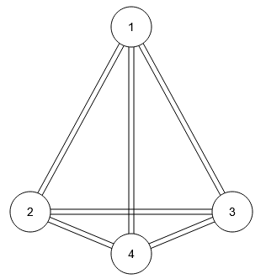
7). Minimum Track Crossings (Turán’s problem).
The story: The Hungarian Jewish mathematician Pál Turán was forced into labor by the Hungarian government at a brick factory during World War II. According to the story, he was pushing wagons of bricks between kilns and storage yards. He noticed that the wagons would sometimes derail, but it only seemed to happen when the tracks crossed another pair of tracks.
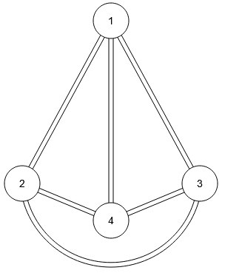
For example, in the top diagram, if you pushed a wagon from 1 to 4, you might derail when the tracks cross. But if you moved the tracks connecting 2 to 3 so they go under 4 (as in the bottom diagram), then there would be 0 track crossings. It’s a slightly longer path, but there’s no chance of derailing.
Turán wondered, for a given set of end-points and tracks, what alternative paths you could make for the tracks to get the smallest possible number of track crossings.
The problem.
Version 1. Given n kilns and m storage yards, what’s the minimum number of track crossings you can get if every kiln must be connected to every storage yard?
Version 2. Given n locations, what’s the minimum number of track crossings you can get if every location must be connected to every other? (The diagrams above correspond to this version of the problem when $n=4$ )
These problems are central to an area of math called graph theory. In graph theory, the locations you’re connecting are called nodes and the tracks connecting them are called edges. The nodes and edges together form a graph. The graph is defined just by the nodes and which nodes are connected by edges; not by the specific drawing showing the paths for the edges. The crossing number of a graph is the smallest number of edge-crossings possible when making a drawing of the graph.

• Kobon triangle problem: the max number of non-overlapping triangles formable by n straight lines. Known exactly only for small n; the general formula is conjectural.
• No-three-in-line problem: max points you can place in an n×n grid so that no three are collinear. Conjectured to be close to 2n, but the exact value is unknown for large n and gets harder to pin down as n grows — very much in the spirit of your two examples, but still unsolved.
Self-avoiding walks on the square lattice: count walks of length n that never revisit a square. No closed-form formula exists, and even the asymptotic growth rate (the "connective constant") is unknown for the square lattice — though it was proven exactly for the hexagonal lattice in 2010 ($\sqrt{2+\sqrt{2}}$), a genuinely striking result showing the square lattice case is a different beast.
Stamp/map folding problems: how many ways can you fold a 1×n strip of stamps (respecting rigidity)? Sequences are only known computationally out to fairly small n; no formula is known.

